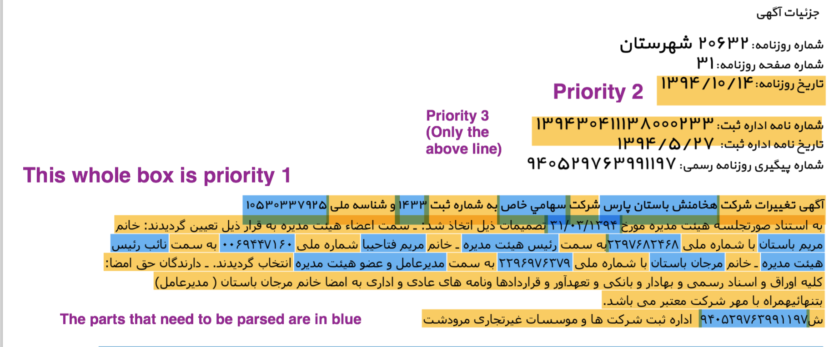

**Parsing Priorities**

Priority 1:



* The first part is the date of the meeting.
* The rest are the names of the shareholders and their Social Security Numbers

Priority 2:



* These are all the titles of the board members (chairman of the board, vice chairman of the board, CEO,...)

Priority 3:



* From left to right: 1. The registration number of the newspaper, 2. Name of the company, 3. Type of the company (Private, Public, LLC, …), 4. Registration number of the company, 5. National ID Number of the company

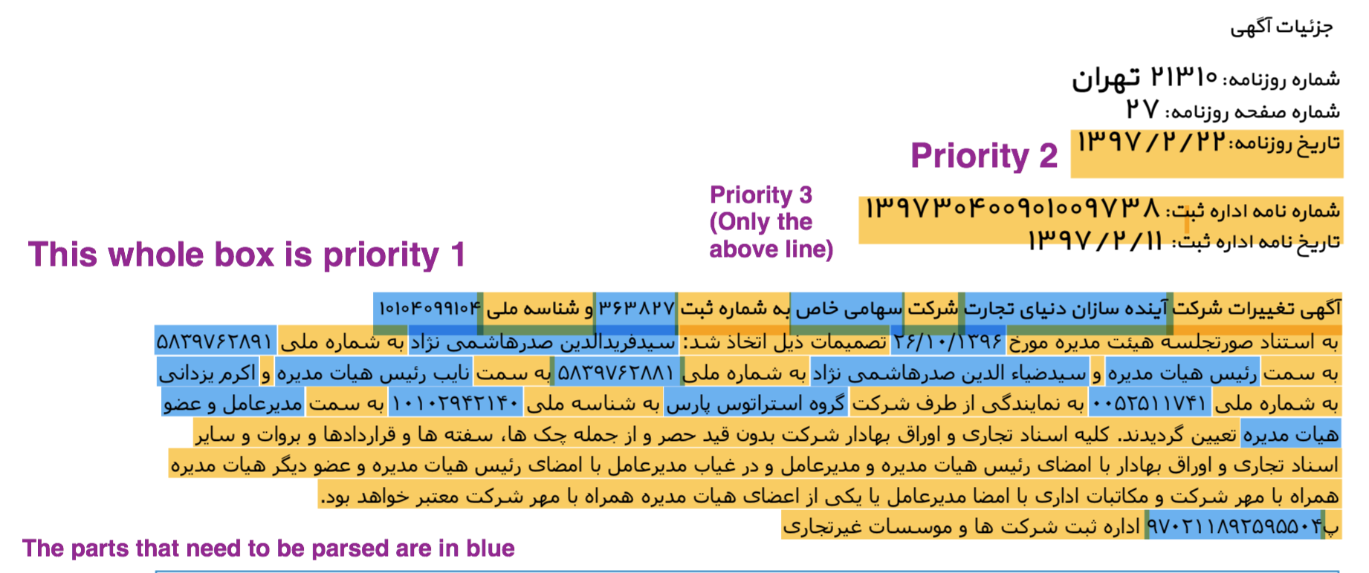

Note: This ad has more info than the previous example. Other than the board members, it also has the name of the shareholder of the company.

Priority 1:



* Date of the meeting and the name and the SSN of the board members

Priority 2:



* Name of the company that is a shareholder and its National ID Number

Priority 3:



* These are all the titles of the board members (chairman of the board, vice chairman of the board, CEO,...)

Priority 4:

 

* From left to right: 1. The registration number of the newspaper, 2. Name of the company, 3. Type of the company (Private, Public, LLC, …), 4. Registration number of the company, 5. National ID Number of the company

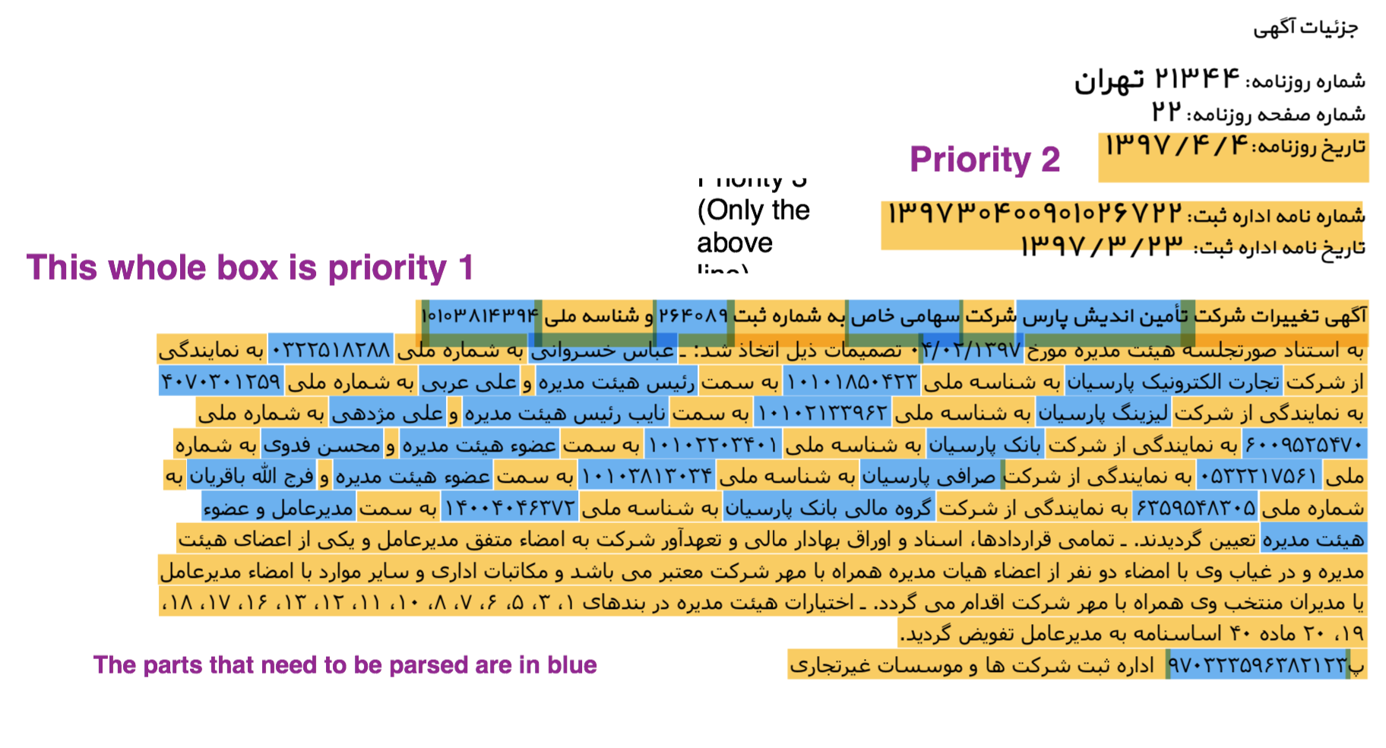Note: Like the above ad, this one also has the names of the shareholders of the company.

Priority 1:



* Date of the meeting and the name and the SSN of the board members

Priority 2:



* Name of the shareholders and their National ID Number

Priority 3:



* These are all the titles of the board members (chairman of the board, vice chairman of the board, CEO,...)

Priority 4:



* From left to right: 1. The registration number of the newspaper, 2. Name of the company, 3. Type of the company (Private, Public, LLC, …), 4. Registration number of the company, 5. National ID Number of the company

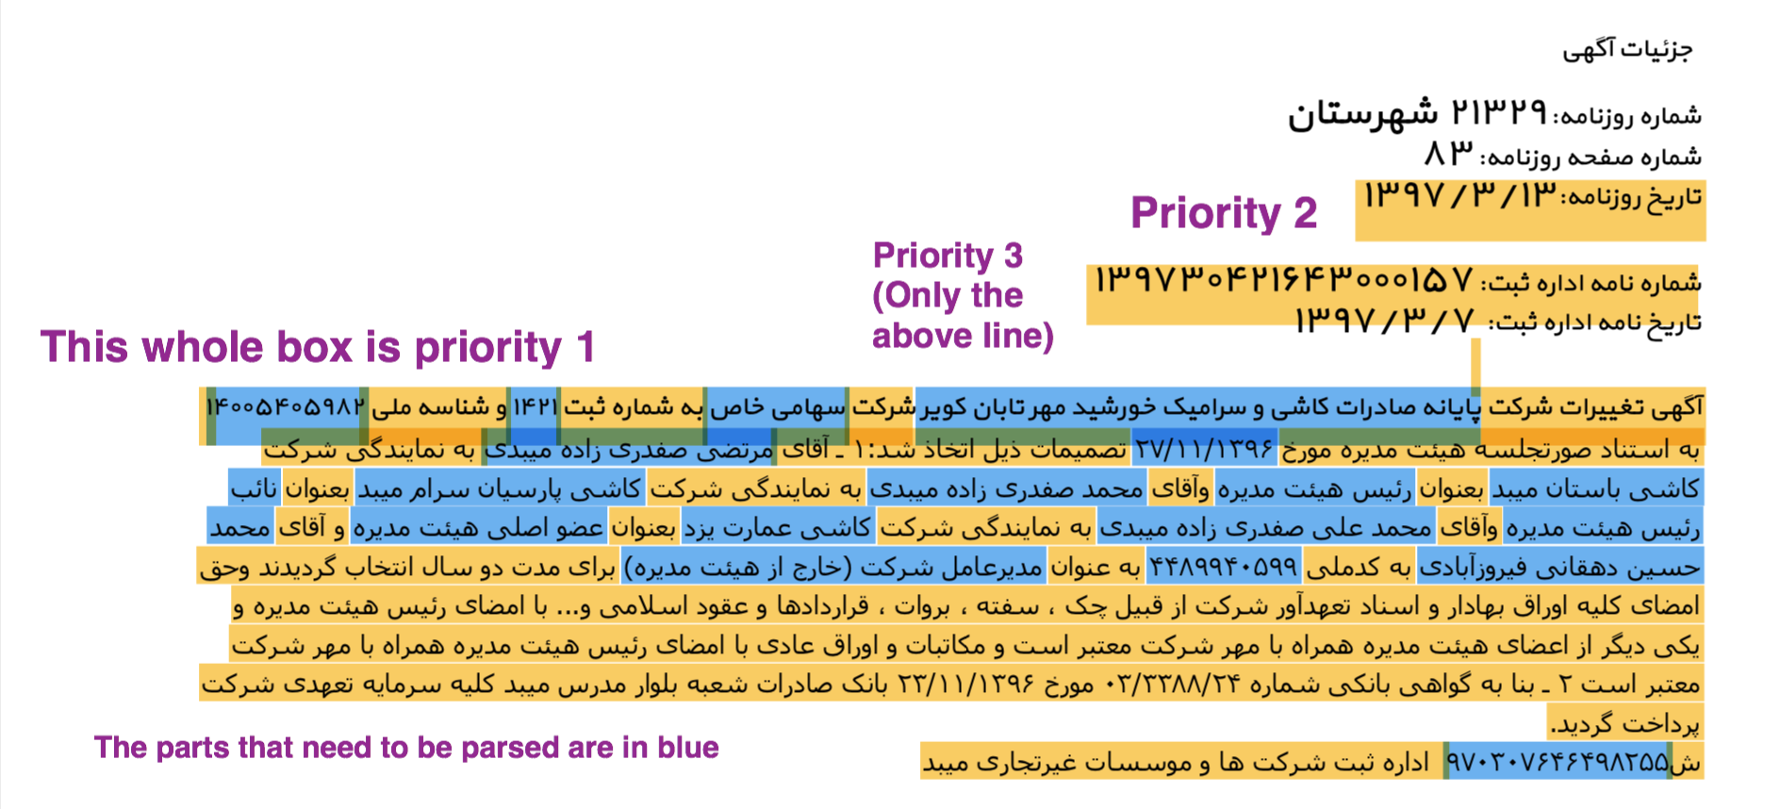

Note: Like the above ad, this one also has the names of the shareholders of the company.

Priority 1:



* Date of the meeting and the name and the SSN of the board members (Here only one SSN is provided)

Priority 2:



* Name of the shareholders (In this example the Nation ID Number of companies is not provided)

Priority 3:



* These are all the titles of the board members (chairman of the board, vice chairman of the board, CEO,...)

Priority 4:



* From left to right: 1. The registration number of the newspaper, 2. Name of the company, 3. Type of the company (Private, Public, LLC, …), 4. Registration number of the company, 5. National ID Number of the company

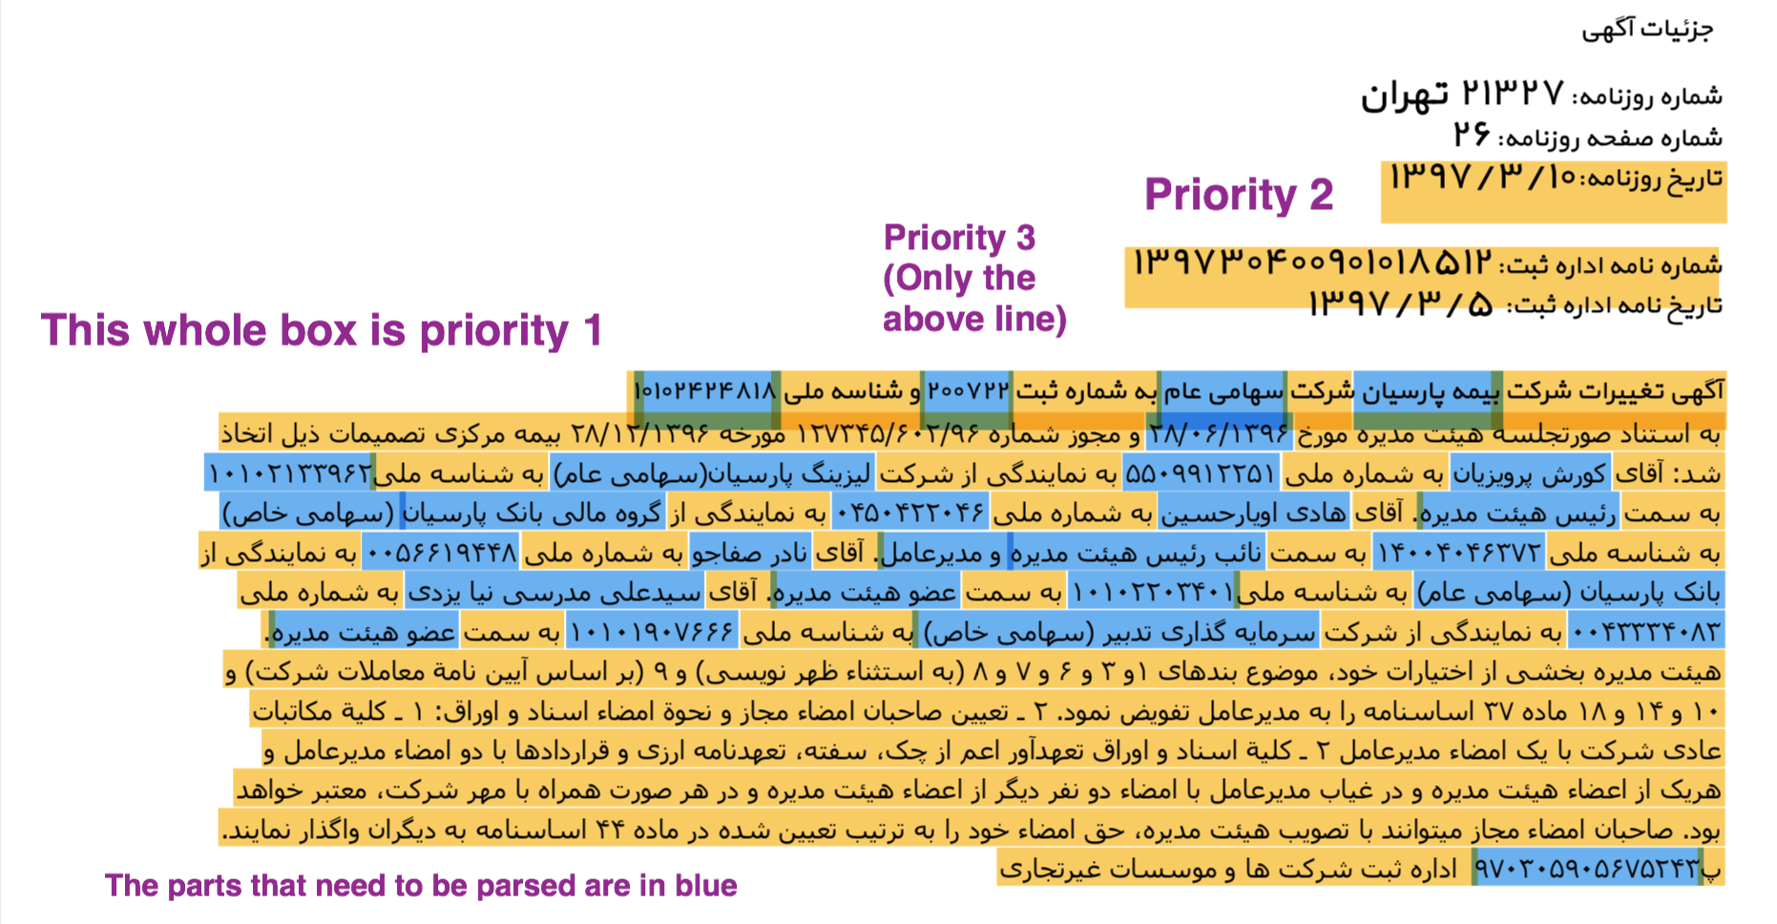

Note: Like the above ad, this one also has the names of the shareholders of the company.

Priority 1:



* Date of the meeting and the name and the SSN of the board members

Priority 2:



* Name of the shareholders and their National ID Number

Priority 3:



* These are all the titles of the board members (chairman of the board, vice chairman of the board, CEO,...)

Priority 4:



* From left to right: 1. The registration number of the newspaper, 2. Name of the company, 3. Type of the company (Private, Public, LLC, …), 4. Registration number of the company, 5. National ID Number of the company